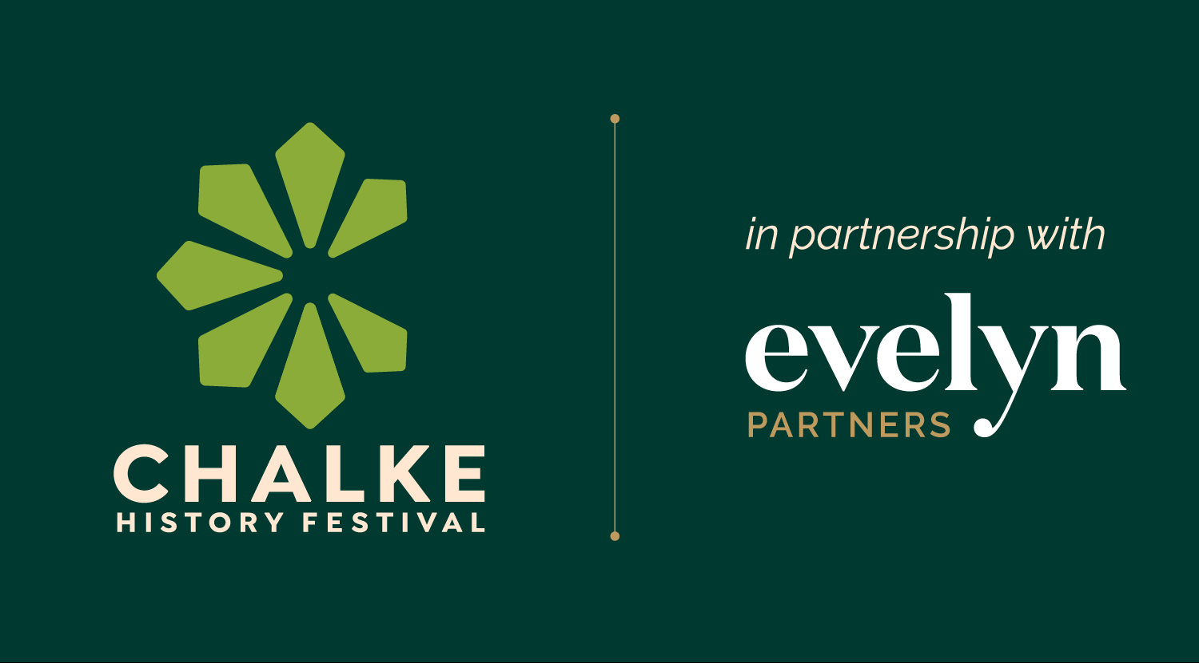

Chalke History Festival - bringing together the most passionate minds in historical investigation and debate from 23rd to 29th June 2025

Twilight Talks on Monday and Tuesday evening

First living history experts announced and new After Dark area created

Further household names added to distinguished line-up of speakers

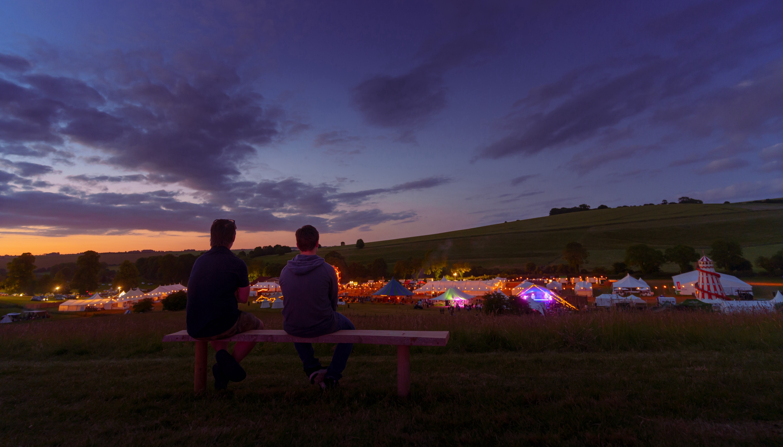
Chalke History Festival site at night – photo credit: Ash Mills

The line-up for this summer’s Chalke History Festival (23rd to 29th June) already boasts a stellar list of world-renowned historians, the very best living history experts in the land and household names to make your mouth water. In a fresh approach for 2025, the festival will look and maybe feel a little different, with a stunning new site layout, bigger tents and some newly created areas to engage the crowd and get people talking about history in a more informal way. Supported by lead partner Evelyn Partners, the festival will undoubtedly be one of the must-attend attractions of the summer season, bringing together passionate thought-leaders and the most informed living historians around, happy to share their extraordinary and unique knowledge with curious visitors and students eager to learn more.

Twilight Talks on the Monday and Tuesday evenings will kick-start the festival with a series of lively discussions, including events on revolution, republic and the end of liberal democracy, all the King’s men at the court of James I (to tie in with the anniversary of his death in 1625) and the legacy of Wolf Hall creator Hilary Mantel. With a new and improved ticketing system – with entry tickets now including access to all festival talks at no extra charge – buying a ticket to listen to these incredible talks could not be easier. All under 16s will be free and early bird prices are available until 13th April.
An exciting new After Dark area is also being created for the first time to encourage historical fireside chat, with a relaxed atmosphere for exchanging ideas and a fire pit to keep festival goers warm after sundown. With a convenient pop-up bar for those looking for a last nightcap, there will be a different programme of music, readings and storytelling every evening, giving fellow history enthusiasts a chance to bond under the stars. The line-up for this area will be announced in due course.

Chalke is famous for attracting a host of famous faces and highly respected names, and this June is no exception. To mark the 10th anniversary of his international bestselling The Silk Roads, Peter Frankopan returns to discuss this landmark work and to assess how the world has changed ten years on. Helen Carr, described by Sathnam Sanghera as ‘one of the most talented and compelling historians of her generation', will be discussing her new book Sceptred Isle: A New History of the Fourteenth Century. Journalist and former Secretary of State for Education Michael Gove will be looking back at his time in UK politics, and co-host of the hugely popular podcast ‘The Rest is History’ and bestselling author Tom Holland will be presenting his masterful new translation of Suetonius' renowned biography of the Caesars. Plus, Anne Sebba will be sharing her harrowing and powerful account of The Women’s Orchestra of Auschwitz.

2025 also sees the 20th anniversary of the no:1 bestselling phenomenon Labyrinth by Kate Mosse who will be retelling the story through the lens of the Albigensian ‘Crusade’. British designer, writer and broadcaster Kevin McCloud makes his debut festival appearance, talking about his twenty-five years of presenting Channel 4’s Grand Designs, and also about the importance of saving our national heritage. Former Home Secretary and Shadow Chancellor Alan Johnson makes a welcome return to talk about Harold Wilson who served as the UK’s Prime Minister twice in the 1960s and 70s. And British investigative journalist John Sweeney will be back to talk about his explosive account of how Putin poisoned Alexei Navalny in his latest book Murder in the Gulag.

On the Friday evening, it will be time to get in touch with your inner Freddie Mercury as one of the UK’s premier tribute bands, Supersonic Queen, takes to the stage. Known for its uniquely dynamic recreation of Queen's iconic music festival performances, this totally live 5-piece band will deliver a night to remember. So, dust off those leather trousers, dig out that old skinny white vest, start grooming that moustache, and start practising your ‘Radio Ga Ga’, as live music is coming to Chalke like you’ve never seen it before.

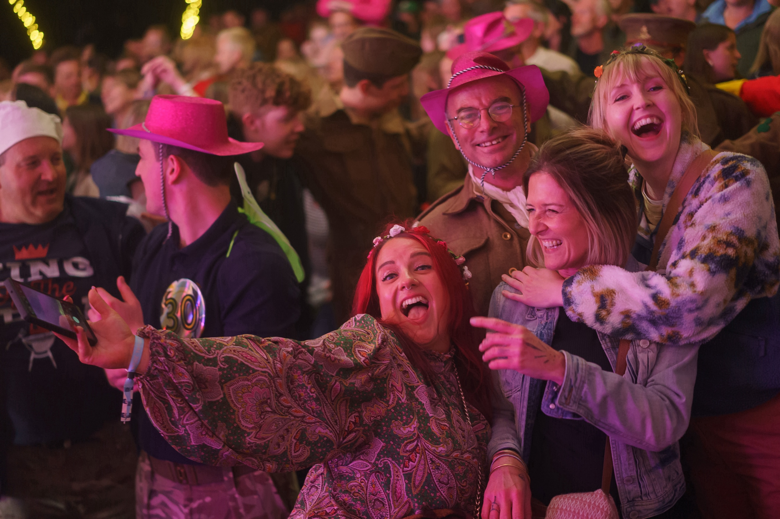
Partying at the Chalke History Festival – photo credit: Ash Mills

Visitors will be transported back to the Elizabethan period as the On Cue Theatre Company brings Shakespeare to Chalke throughout the festival week for the first time, with workshops and lively and dynamic performances of Henry V. Performance lovers will discover how the Elizabethan players originally performed with minimal rehearsal, no director, and working from cue scripts. In addition, the Rattlebox Theatre returns, this time bringing the legends of Robin Hood to life through dynamic puppetry, colourful acting, and live music on medieval instruments.

The Chalke History Festival for Schools has welcomed over 21,000 children since its launch and is a hugely popular event in the calendar for both students and teachers. With three days of history, featuring a wide range of curriculum-based subjects, it makes a major contribution to history education and each year brings history alive in new and exciting ways. The dates for 2025 have been announced: Monday 23rd June for primary schools (Years 6, 7, 8, and 9), Tuesday 24th June for secondary schools (Years 10, 11, and 12), and Wednesday 25th June is a SEND day, which is open to all ages and which provides a programme that is less structured and takes place in a quieter environment. Topics and themes for this year include VE Day, the Neolithic and Bronze Ages, the History of Medicine, Iron Age building methods, and Empire.

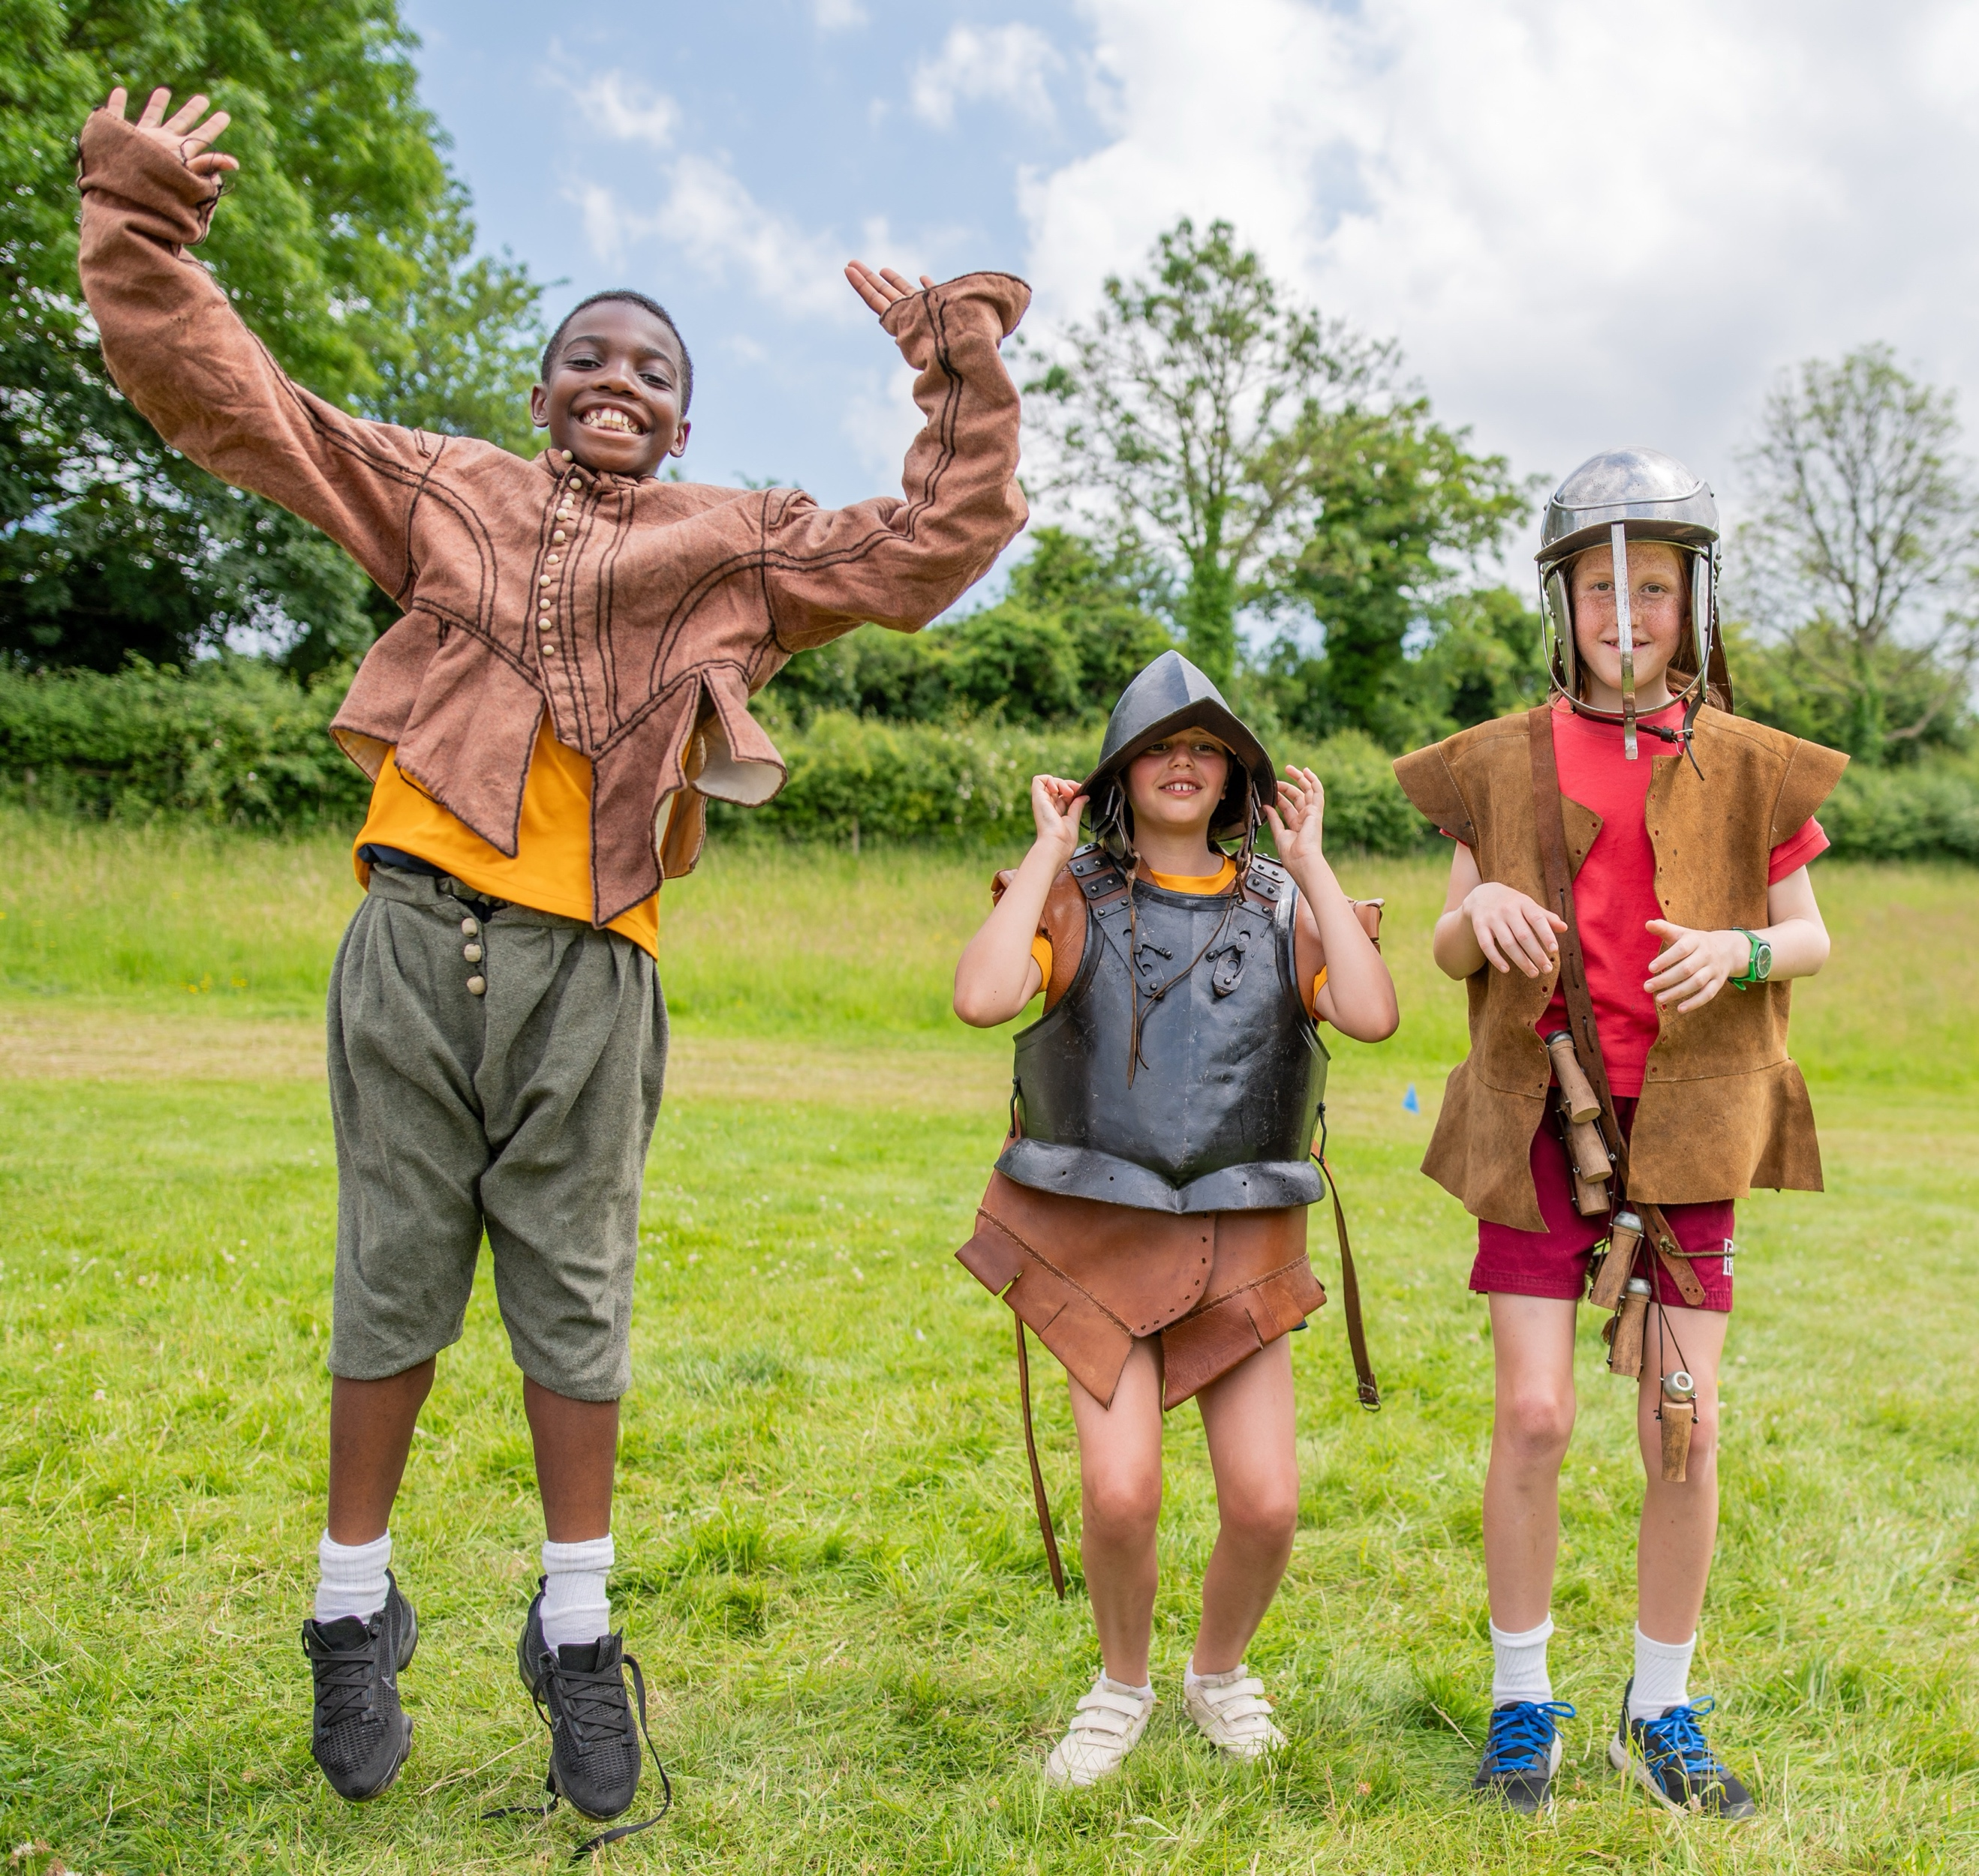
School children dressing up at Chalke – photo credit: Martin Cook

Elsewhere at the festival, the Remaking History team will be exploring the gruesome history of execution as they attempt to recreate an eighteenth-century guillotine, and at the thirteenth-century cutler’s workshop, Tom Timbrell of Heritage Blades and Emma Harrison of Bog Born Crafts will be smelting and refining iron to produce cutlery. And Kate Vigurs will be regaling the crowds with extraordinary facts about the SOE’s missing agents.

The Chalke History Festival will take place at Church Bottom, Broad Chalke, Salisbury, Wiltshire, SP5 5DP. For more details about the festival, please visit our website at www.chalkefestival.com Follow all the news on X at @ChalkeFestival, on Instagram at @chalkehistoryfestival and on Facebook.

About the Chalke History Festival

Attracting the finest and most distinguished historians, academics, leading thinkers, and writers from the UK and abroad, the Chalke History Festival is now firmly established as one of the must-attend events of the festival summer. Taking place on a 70-acre farm, in the heart of the Wessex countryside just outside Salisbury in Wiltshire, it blends inspiring literary talks, discussions and panels with eye-catching and entertaining living history and historical experiences.
About Evelyn Partners
We are a multi award-winning wealth management group, with a rich heritage going back 188 years. With £62.7 billion of assets under management (as at 30 September 2024) we are one the largest UK wealth managers, with offices across the UK as well as the Republic of Ireland and the Channel Islands.
Our purpose is ‘to place the power of good advice into more hands,’ which we deliver through a range of services. Our expertise includes financial planning and investment management, enabling us to offer clients a truly holistic wealth management service. Through Bestinvest, we also provide an online investment platform and coaching service for investors who prefer to make their own decisions. For further information please visit: www.evelyn.com.

