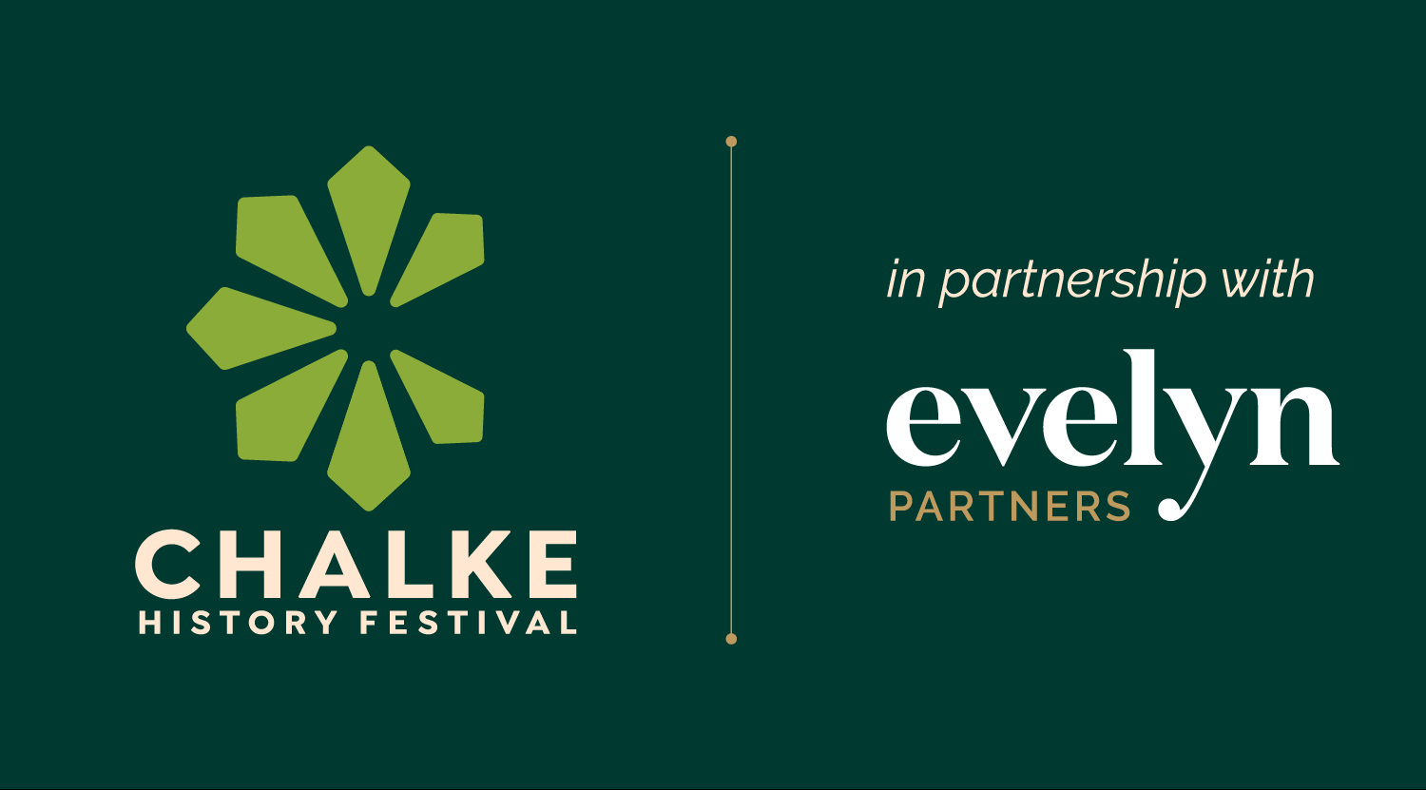

Chalke History Festival – the world’s leading historians and living history experts, all in one place from 23rd to 29th June 2025

A chance to reexamine the past as we navigate the complex world of today

The greatest historical show in town: full line-up announced and tickets now on sale

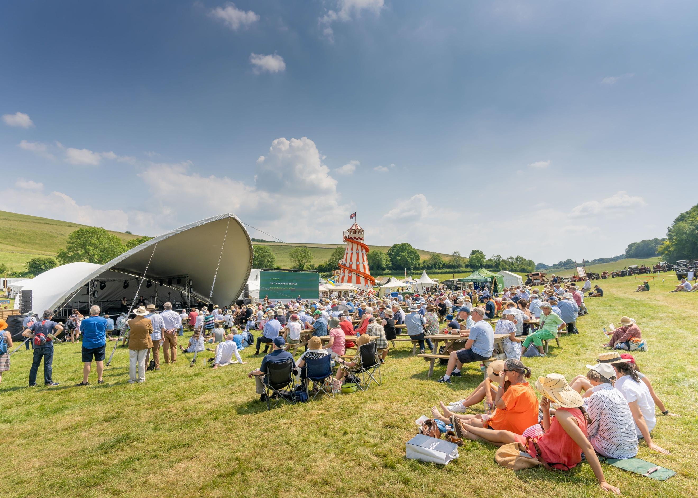
Festival goers attend a stage talk at Chalke – photo credit: Ash Mills

The full line-up for the 2025 Chalke History Festival, supported by lead partner Evelyn Partners, has been announced and tickets are now on sale. Top historians from around the globe, and the best living history experts in their field, will meet in the glorious setting of the Chalke Valley in Wiltshire from 23rd to 29th June, sharing their vast knowledge and experience with history fans, students and families alike. Chalke is now firmly cemented into the summer festival calendar as one of the top cultural must-attend events, attracting a wide audience from both home and abroad, and making headlines with its top-level list of VIP names and attendees.

The speaker line-up this year boasts a plethora of household names, including: former White House Communications Director Anthony Scaramucci, social media sensation and historian Alice Loxton, co-host of the hugely popular podcast The Rest is History and bestselling author Tom Holland, historian and TV presenter Helen Castor, the Milbank Family Senior Fellow at the Hoover Institution (Stanford) and author Niall Ferguson, international bestselling writer Kate Mosse, broadcaster, curator, critic and author William Dalrymple, the UK’s top-selling true crime writer Kate Summerscale, and British designer, writer and Grand Designs presenter Kevin McCloud.

The festival is also thrilled to welcome back beloved author, TV icon and Monty Python star, Michael Palin who will be offering a captivating glimpse into a decade of change, challenge, and adventure. Amidst the uncertainty of the 21st century, his insatiable curiosity has driven him through four landmark travel documentaries – Hemingway Adventure, Sahara, Himalaya, and New Europe – confirming his place as one of the nation’s most adored TV travellers. As he talks with warmth and wit about his latest book There And Back: Diaries 1999-2009 he will reflect on family, fame, and the Pythons, culminating in his greatest new role: a devoted grandfather. Photo credit: Alamy

Elsewhere on the bustling festival site, visitors can immerse themselves in a wide and exciting range of living history talks and activities. The Time Travellers Kitchen will continue to travel through British culinary history, this year stopping in 1940 with the introduction of rationing during the Second World War and preparing food from that period. Professional sailmaker Sarah Liscoe of The Historical Sailmaker will explore the history of sailmaking from the 1400s to 1800s, demonstrating a unique and endangered heritage craft and its role through history. Plus, ticketed experiences such as the hugely popular SOE Training Camp, Tomahawk Axe Throwing, Have-A-Go Archery and Cowboy Circus Skills will keep the whole family entertained for hours. Live music every day will get everyone up on their feet and dancing until the sun goes down, with the line-up including: The Branflakes, The D-Day Darlings, Supersonic Queen, new indie-folk band Good Habits, and Still Moving DJs.

Those fascinated by images of knights on horseback can take themselves back to England in the late Middle Ages and discover the importance of the medieval warhorse with stunning performances by the experts from Historic Equitation. Bringing together the latest archaeological and historical research and their own impressive horsemanship skills, the team will explain where horses were bred and trained, the role they played in medieval society and conflict, and the armour that was used at the time.

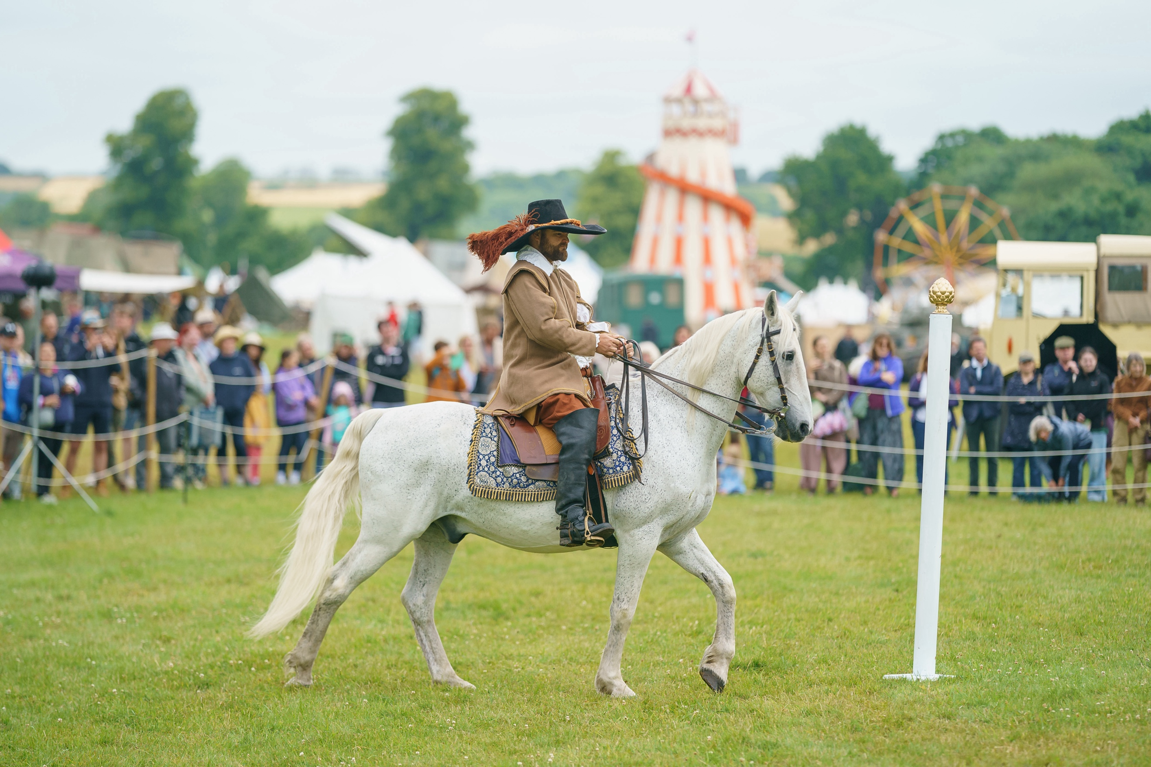
Historic Equitation at Chalke History Festival – photo credit: Ash Mills

2025 is a significant year for historical anniversaries and one of the biggest is the marking of 400 hundred years since the death of James I. Lucy Hughes-Hallett and Gareth Russell will explore the powerful men at the heart of James I’s court, from trusted confidants to passionate lovers. Anna Whitelock will uncover how James I’s vision laid the foundations for the British Empire, reshaping the nation's future and global influence, from the Mayflower to key alliances with Persia, and opening new chapters in world trade and exploration. This year also sees the 250th anniversary of the birth of Jane Austen and, to celebrate this milestone, Gill Hornby and Helena Kelly will be discussing the woman behind the myth and what her novels can tell us about real life in Regency Britain.

In May this year the nation will be commemorating 80 years since VE Day and the end of WW2 in Europe. There will be plenty of events at the festival to highlight this important anniversary, including a talk by James Holland and Al Murray who will bring their trademark insight and wit to the gripping story of how the Second World War truly ended, uncovering the drama, diplomacy, and untold human stories behind the eight surrenders that reshaped the world. International bestselling author Antony Beevor will also be returning to Chalke to discuss one of the most momentous moments of 20th century history: the death of Hitler, the fall of Berlin in 1945 and the collapse of the Third Reich. And the focus of this year’s Second World War Morning will be the war in the Far East and the Pacific – experts such as Richard Dannatt, Rob Lyman, Frank Close, Phil Craig and Saul David will come together with James Holland to examine the war in Southeast Asia, the bloody campaign of Okinawa, the significance of dropping the atomic bomb twice on Japan, and the Korean War of the 1950s.

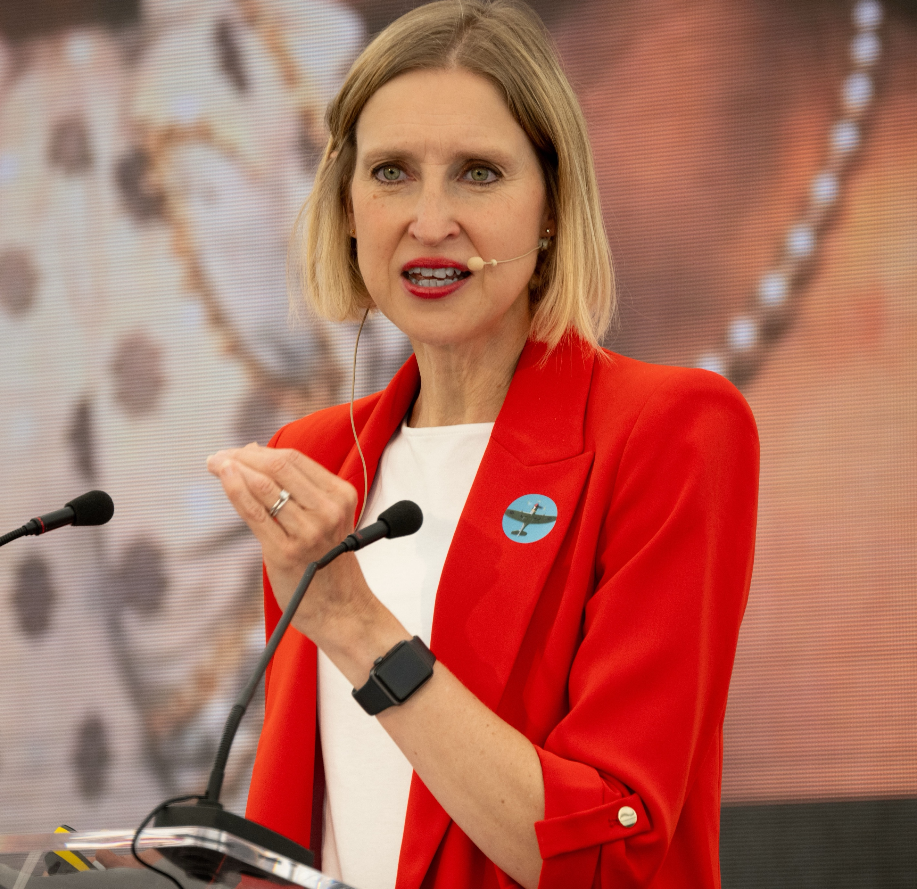
Tracy Borman at Chalke History Festival – photo credit: Graham Smith

Dame Hilary Mantel redefined historical fiction with her masterful, immersive storytelling in the Wolf Hall trilogy, offering a radically different portrayal of Thomas Cromwell. On the opening evening at Chalke there will be a panel discussion about the extraordinary legacy left by Mantel led by the renowned historian and broadcaster Tracy Borman, alongside Peter Florence and historical consultant to the TV programme Owen Emmerson, during which the role of historical fiction will be discussed and authenticity in screen adaptations examined. Later in the week, the acclaimed Director of the two BBC TV Wolf Hall series, Peter Kosminsky, will be talking about his 40+ years of working in television and film.

For the first time entry tickets to the festival now include access to all the talks at no extra charge, so buying a ticket to these incredible events and activities could not be easier. All under 16s are free and student discounted rates are also available.

Members of The Chalke History Club will be able to reserve seats at the talks from Monday 14th April onwards.

The Chalke History Festival will take place at Church Bottom, Broad Chalke, Salisbury, Wiltshire, SP5 5DP. For more details about the festival, please visit our website at www.chalkefestival.com Follow all the news on X at @ChalkeFestival, on Instagram at @chalkehistoryfestival and on Facebook.

About the Chalke History Festival

Attracting the finest and most distinguished historians, academics, leading thinkers, and writers from the UK and abroad, the Chalke History Festival is now firmly established as one of the must-attend events of the festival summer. Taking place on a 70-acre farm, in the heart of the Wessex countryside just outside Salisbury in Wiltshire, it blends inspiring literary talks, discussions and panels with eye-catching and entertaining living history and historical experiences.
About Evelyn Partners
We are a multi award-winning wealth management group, with a rich heritage going back 188 years. With £62.7 billion of assets under management (as at 30 September 2024) we are one the largest UK wealth managers, with offices across the UK as well as the Republic of Ireland and the Channel Islands.
Our purpose is ‘to place the power of good advice into more hands,’ which we deliver through a range of services. Our expertise includes financial planning and investment management, enabling us to offer clients a truly holistic wealth management service. Through Bestinvest, we also provide an online investment platform and coaching service for investors who prefer to make their own decisions. For further information please visit: www.evelyn.com.

