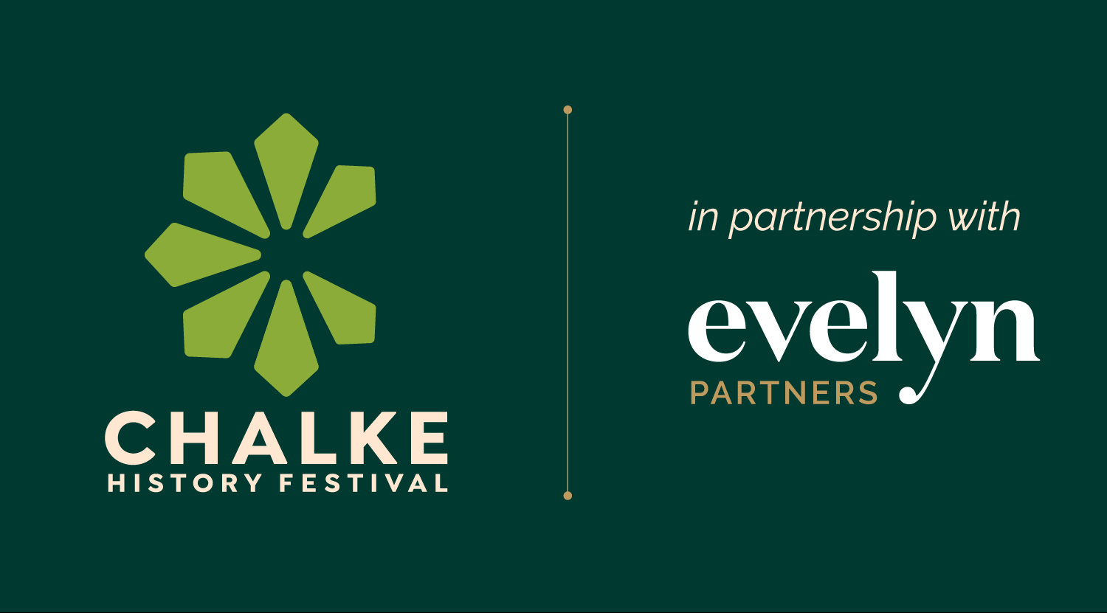

23-29th June 2025

Chalke History Festival - grappling with the past to understand the future

Festival announces Evelyn Partners as new lead partner in major
multi-year deal

Headline acts already confirmed in star-studded programme

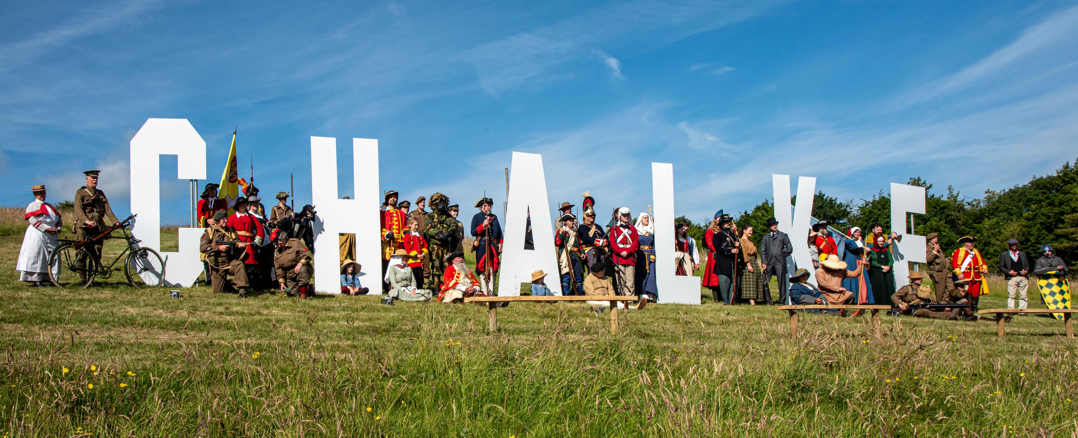
Chalke History Festival – photo credit: Graham Smith

Chalke History Festival is without doubt now one of the highlights of the summer events calendar and this year it will take place from 23rd to 29th June. For one week, the world’s most passionate minds in historical investigation and debate come together in the stunning surroundings of the Chalke Valley in Wiltshire, providing fresh new perspectives to the past and bringing history alive through its sights, sounds and experiences. This annual event has all the elements of the most talked-about English summer festivals: a star-studded programme to delight all the family, mouth-watering local food and drink, a plethora of activities to keep the children busy for days, camping and glamping under the midsummer night sky, and the best party atmosphere in town.

To kick-off 2025, Chalke is delighted to announce that the multi award-winning wealth management group Evelyn Partners is to be its new lead festival partner. At a time when the future financial security of literary festivals and key cultural events across the UK has been under intense scrutiny and in the media spotlight, this new major multi-year deal is both important and welcome.

James Holland, Creative Director and Co-Founder of the Chalke History Festival, said: “It’s wonderful that such a major player as Evelyn Partners is supporting an important UK festival at this time. We are extremely proud to be embarking on a multi-year partnership, one that will do much to ensure the Chalke History Festival can grow and develop. Our 2025 programme is already shaping up to be our best ever and while we all want everyone who comes to enjoy themselves and have a wonderful time, we also all very strongly believe that history is vitally important and that so too are cultural festivals such as ours. History is the surest way to unlock our futures, and the first step to securing our future is to understand our past. Making decisions about tomorrow is best done armed with the lessons of yesterday. It is extremely heartening to know Evelyn Partners will be helping us fulfil and expand our mission to bring the rich and enthralling story of our past to as many people as possible.”

Andrew Middleton, Group Chief Marketing and Commercial Officer at Evelyn Partners commented: “We are delighted to be lead partner to the Chalke History Festival. In its quest to understand and popularise history, Chalke History Festival provides the stories, lessons and insights that can be used to make sense of “what’s next for the world?” – a question we have front of mind when supporting our clients with what’s next for them and their money. We’re looking forward to a really successful event.”
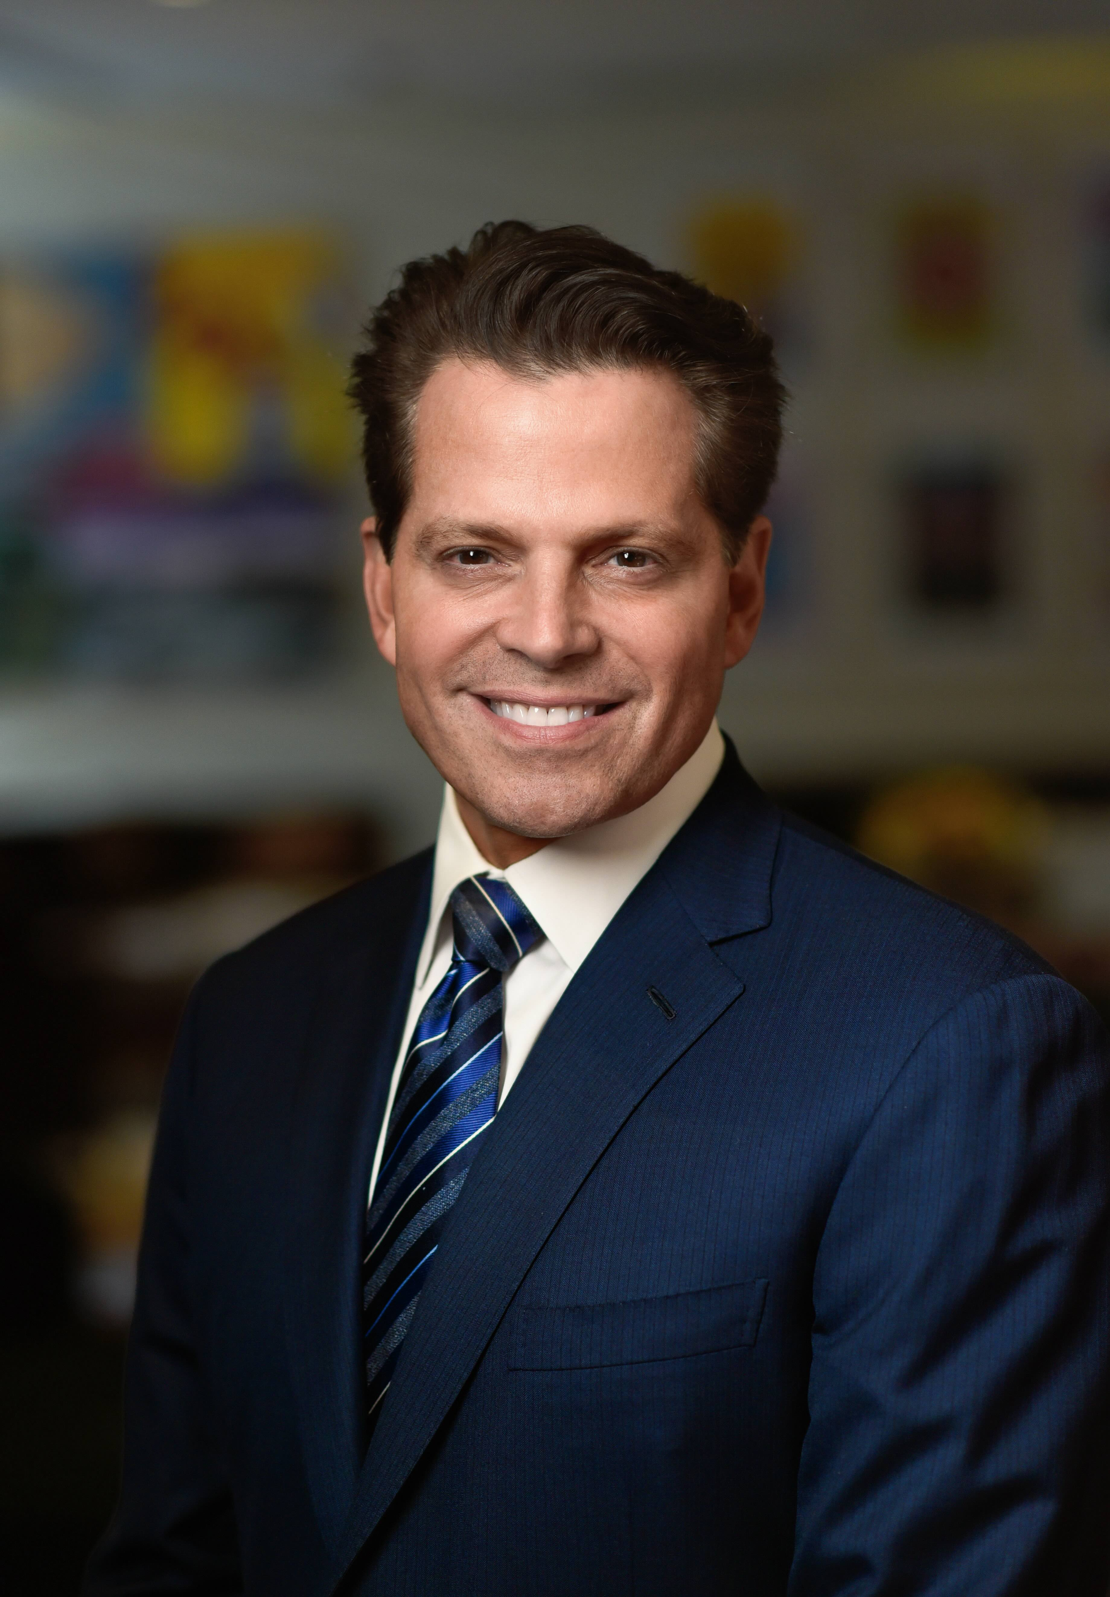
The exciting line-up for the festival programme this summer is already taking shape with Anthony Scaramucci confirmed as one of the headline acts and billed to take part in a number of events. Nicknamed ‘The Mooch’, he served on President Donald Trump’s Presidential Transition Team Executive Committee in 2016 and briefly as White House Communications Director in July 2017. He is currently the co-host of two hugely popular podcasts, “The Rest Is Politics US” and “Open Book,” and is also the founder and managing partner of SkyBridge, a global alternative investment firm, and founder and chairman of SALT, a global thought leadership forum and venture studio. He has authored six books, including The Little Book of Bitcoin.
Other VIPs also slated to appear at Chalke this June include: the author behind the major BBC TV drama SAS: Rogue Heroes Ben Macintyre, who will be talking about the 1980 Iranian Embassy Siege; social media sensation Alice Loxton, who will be discussing her latest book A History of Britain in 18 Young Lives; leading social philosopher Roman Krznaric, who will unearth fascinating insights from the last 1000 years of world history that could help us confront the most urgent challenges facing humanity in the twenty-first century; plus, Tom Parker-Bowles, who will be recounting fascinating tales of royal kitchens, chefs and culinary traditions and discussing scrumptious recipes from Queen Victoria to King Charles III.
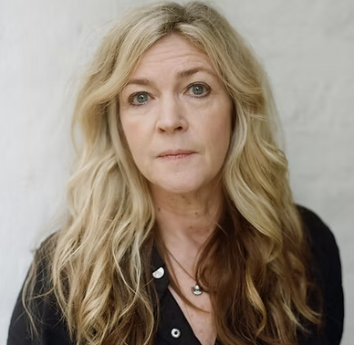
Also confirmed are: the UK’s top-selling true crime writer, and the bestselling author of The Suspicions of Mr Whicher Kate Summerscale (pictured, right), who will be presenting her latest page-turner The Murders at 10 Rillington Place; one of the world’s leading historians of modern Germany Richard Evans who will be discussing Hitler’s inner circle and asking just how far individuals will go when so many normal moral constraints have disappeared; bestselling medieval historian and TV presenter Helen Castor who will be recounting the lives and reigns of Richard II and Henry IV, two cousins whose rivalry brought their nation to the brink of disintegration; and renowned author, journalist and broadcaster Max Hastings who will be telling the gripping story of how British and American troops landed on Sword Beach on D-Day.

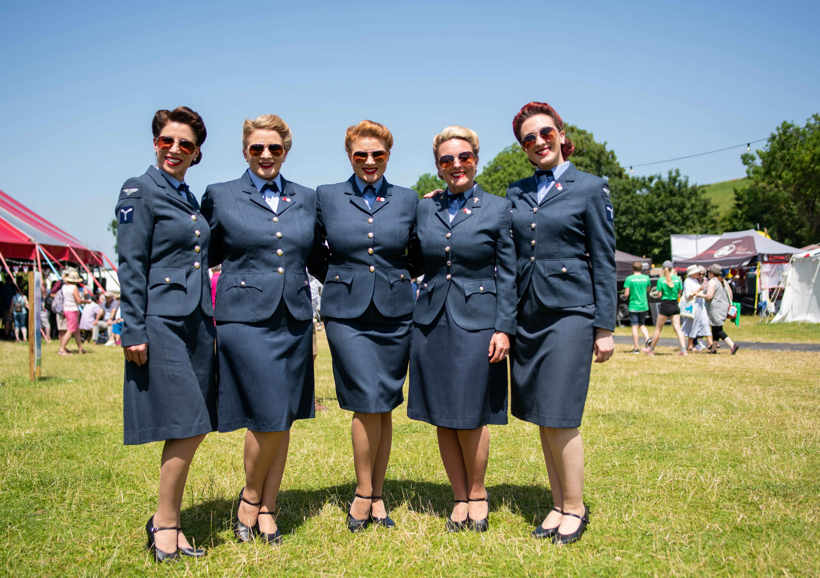
The D-Day Darlings at Chalke History Festival – photo credit: Martin Cook

Elsewhere at the festival, ITV’s Britain’s Got Talent finalists The D-Day Darlings will return to Chalke to entertain the crowds on the Saturday night and are bound to get the audience, both young and old, up on their feet and onto the dancefloor. With their hugely popular repertoire of WW2 songs, they will be continuing their mission to keep the wartime spirit alive and inspiring the next generation.

The Chalke History Festival will take place at Church Bottom, Broad Chalke, Salisbury, Wiltshire, SP5 5DP. For more details about the festival, please visit our website at www.chalkefestival.com Follow all the news on X at @ChalkeFestival, on Instagram at @chalkehistoryfestival and on Facebook.

About the Chalke History Festival

Attracting the finest and most distinguished historians, academics, leading thinkers, and writers from the UK and abroad, the Chalke History Festival is now firmly established as one of the must-attend events of the festival summer. Taking place on a 70-acre farm, in the heart of the Wessex countryside just outside Salisbury in Wiltshire, it blends inspiring literary talks, discussions and panels with eye-catching and entertaining living history and historical experiences.
About Evelyn Partners
We are a multi award-winning wealth management group, with a rich heritage going back 188 years. With £62.7 billion of assets under management (as at 30 September 2024) we are one the largest UK wealth managers, with offices across the UK as well as the Republic of Ireland and the Channel Islands.
Our purpose is ‘to place the power of good advice into more hands,’ which we deliver through a range of services. Our expertise includes financial planning and investment management, enabling us to offer clients a truly holistic wealth management service. Through Bestinvest, we also provide an online investment platform and coaching service for investors who prefer to make their own decisions. For further information please visit: www.evelyn.com.

